# **Application: Moth-eye SEM image analysis**

## **4.1 Overview**

The Moth-eye surfaces refer to hexagonal arrays which are closely packed surface asperities with anti-reflective properties. The dimensions of the structure are very small in comparison with the wavelength of light. In nature, these structures can be found in the eyes and wings of some species of moths, butterflies, and flies. In these insect species, the function of these structures is to increase the visual sensitivity in the eyes and have a camouflaging effect on the wings. It is possible to fabricate these structures artificially for various applications, such as display technologies and photovoltaics. It is notable that these structures are generally 250 nm in height and with a spacing of approximately 200 to 250 nm. These structures reduce the reflectance of lens from 4% to less than 1%.

The moth-eye images cannot be observed with a normal microscope because these images are smaller than the wavelength of light. In order to observe these structures, an electron microscope is used. In an electron microscope, a beam of electrons is bombarded onto the surface that is being observed. The electrons interact with the surface of the material, which results in releasing various signals. These signals provide information about the composition and structural formation of the samples.

Here, the nanoparticles that are deposited on the surface act as the etching mask, through which hexagonally or stochastically ordered pillars are formed on a diamond substrate. Because of the already high refractive index of the diamond, the imperfections may limit the effectiveness and neutralize the effects of the moth eye texture. Thus, it is important to quantify the sensitivity or insensitivity of the effective transmission/forward diffraction of the incident light with respect to the perturbation of ideal surface topographies.  This work aims to find the structural properties of moth-eye structures using state of the art pattern recognition methods. In this section, we focus on the computation and analysis of following objectives.

* The estimation of colony size (number of structures)
* Counting the defected ratio count of the surface
* The estimation of the size of structure
* The presentation of sampling analysis, structural analysis, and morphological analysis
* The effect of light sensitivity

## **4.2** **Data**

The data used in this work comprises SEM images of different moth structures. In Figure 15, we present few samples of moth-eye structure images.

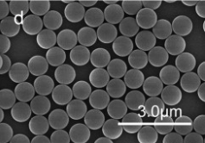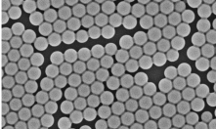

Figure 15: The samples of moth-eye structure images.

## **4.3 Approach**

**4.3.1 Pre-Processing**

First, we pre-process the input moth-eye images by sharpening. We consider a $3×3$ kernel for highlighting the middle pixels. The kernel used for sharpening is presented below.

$$\left(\begin{matrix}-1 & -1 & -1 \\ -1 & 9 & -1 \\ -1 & -1 & -1\end{matrix}\right)$$

The sharpening process is applied on the input moth images as well as on the template images. Please note that the input images refer to data on which the operations are performed, whereas the template images are used to detect the pattern in the input images.

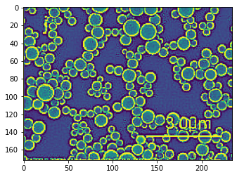

Figure 16:

Before the application of other operations, it is necessary to apply the template matching on the images in order to identify the locations where the moth patterns are present. After applying the template matching on the filtered images, we consider the regions where the matching factor is greater than 65%. This is becasue the moth circles in the images are not same and each circle has its own diameter and intensity value.

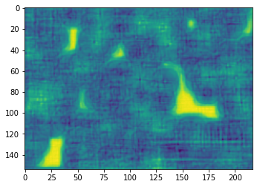

Figure 17:

**4.3.2 Number of Spheres**

After pre-processing the input images, we attempt to count the number of spheres in the images. This can be achieved on the basis of two techniques, i.e., correlation-based technique and Hough transform-based technique.

**4.3.2.1 Correlation-based technique**

In correlation-based algorithm, the idea is to estimate the similarity between to signals (1D or 2D). The correlation operation is applied on the complete image for detecting the circles. When the circle locations are identified, we draw the circles on the grayscale image using OpenCV library. This is visually depicted in Figure 18.

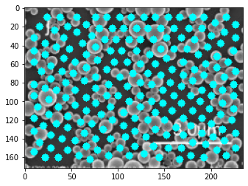

Figure 18: The detected circles drawn on the grayscale image.

**4.3.2.2 Hough-based method**

The Hough transform is a pattern recognition technique which can be used to detect different shapes. It only requires the parameter values of those shapes. A circle is represented by the mathematical expression presented in equation (7).

|  |  |
| --- | --- |
| $${\left(x\right)}^{2}+{\left(y\right)}^{2}=r^{2}$$ | [7] |

The model returns three parameters for each detected circle, when the minimum distance between the circles is defined. If the value is too small, it may lead to the detection of many circles. Contrary, if the value is too large, few circles are detected. Other arguments also include the minimum radius of the circle and the maximum radius of the circle.

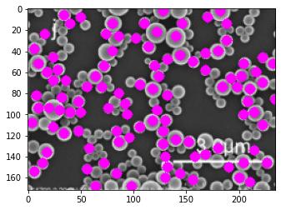

Figure 19:

**4.3.3 Area covered by circles**

In order to compute the area covered by circles, the image which is used to detect the circles on the basis of Hough transform is transformed to a binary image. Please note that the white area represents the region covered by the circles and black regions represents the background. We calculate a histogram to identify the number of pixels which are white and black. The percentage is calculated in terms of pixels.

**4.3.4 Average Separation and Reflection Percentages**

For calculating the average separation between the circles, we first compute the coordinates of the circles. Then, we calculate the Euclidean distance of each circle with every other detected circle. Afterwards, we calculate the average of all the distances.

On the basis of average distance and average diameter, we calculate the reflection percentage by using the mathematical expression presented in equation (8).

|  |  |
| --- | --- |
| $$R= \sqrt{\frac{\left(\left(0.793×\left(meanDiameteravgSphereSepPixel\right)×\left(2\right)\right)+1\right)×\left(3/2\right)-\left(1.52\right)}{\left(\left(0.793×\left(meanDiameteravgSphereSepPixel\right)×\left(2\right)\right)+1\right)×\left(3/2\right)+\left(1.52\right)}}$$ | [8] |

**4.3.5 Good or Bad Images**

Now, we classify the input image as good or bad on basis of the image area covered by the detected circles. We assume that if the image area covered with the circles is greater than 70%, then the image is classified as a good image, otherwise it is classified as a bad image.

4.3.6 Uncovered Regions

4.4 Results

4.5 Discussions